**16bit Carry skip Adder**

module CSK_16bit( input[15:0]a,input c,input[15:0]b,output[16:0]s);

wire t1, t6, t7;

wire [3:0] xor_ab;

RCA_4bit x1(.a(a[3:0]), .b(b[3:0]), .cin(c), .cout(t1), .sum(s[3:0]));

genvar i;

generate

for (i = 0; i < 4; i = i + 1) begin : xor_gen

assign xor_ab[i] = a[i] ^ b[i];

end

endgenerate

assign t6 = &xor_ab;

assign t7 = t6 ? c : t1;

wire q1, q6, q7;

wire [3:0] xor_ab2;

RCA_4bit x2(.a(a[7:4]), .b(b[7:4]), .cin(t7), .cout(q1), .sum(s[7:4]));

genvar j;

generate

for (j = 0; j < 4; j = j + 1) begin : xor_gen2

assign xor_ab2[j] = a[4+j] ^ b[4+j];

end

endgenerate

assign q6 = &xor_ab2;

assign q7 = q6 ? t7 : q1;

wire m1, m6, m7;

wire [3:0] xor_ab3;

RCA_4bit x3(.a(a[11:8]), .b(b[11:8]), .cin(q7), .cout(m1), .sum(s[11:8]));

genvar k;

generate

for (k = 0; k < 4; k = k + 1) begin : xor_gen3

assign xor_ab3[k] = a[8+k] ^ b[8+k];

end

endgenerate

assign m6 = &xor_ab3;

assign m7 = m6 ? q7 : m1;

wire n1, n6;

wire [3:0] xor_ab4;

RCA_4bit x4(.a(a[15:12]), .b(b[15:12]), .cin(m7), .cout(n1), .sum(s[15:12]));

genvar l;

generate

for (l = 0; l < 4; l = l + 1) begin : xor_gen4

assign xor_ab4[l] = a[12+l] ^ b[12+l];

end

endgenerate

assign n6 = &xor_ab4;

assign s[16] = n6 ? m7 : n1;

endmodule

module RCA_4bit(

input [3:0] a, b, input cin,output cout,output [3:0] sum);

wire [3:0] carry;

genvar i;

generate

for (i = 0; i < 4; i = i + 1) begin: adder_block

if (i == 0)

FA_1bit ff ( .a(a[i]),.b(b[i]),.c(cin),.carry(carry[i]),.s(sum[i]));

else if (i == 3)

FA_1bit ff (.a(a[i]),.b(b[i]),.c(carry[i-1]),.carry(cout),.s(sum[i]));

else

FA_1bit ff (.a(a[i]),.b(b[i]),.c(carry[i-1]),.carry(carry[i]),.s(sum[i]));

end

endgenerate

endmodule

module FA_1bit(

input a, b, c,output carry, s );

assign s = a ^ b ^ c;

assign carry = (a & b) | (b & c) | (c & a);

endmodule

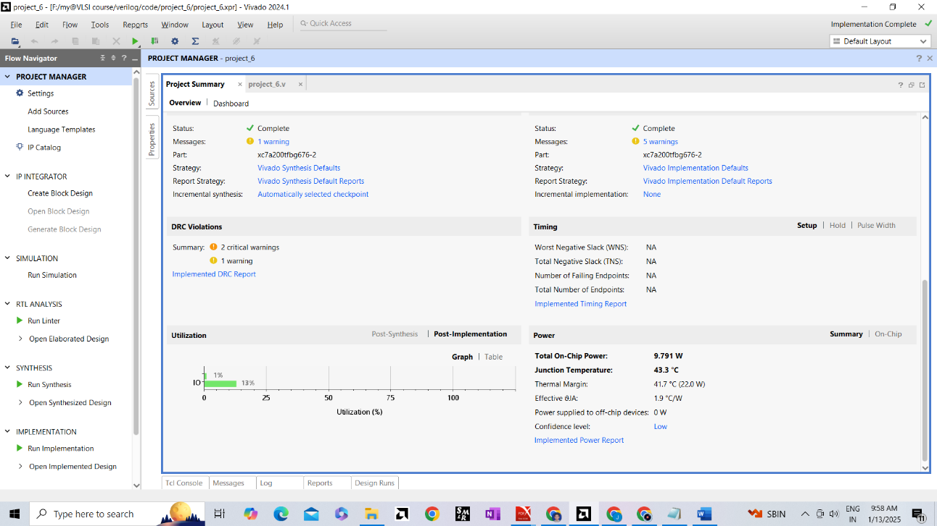

**High-Speed and Low-Power 16-bit Carry Skip Adder Implementation in Verilog**

**Hybrid CSK Adder**

module inverter_cmos (

input a,

output out ,

input vdd, vss

);

wire t1,y;

pmos p1 (y, vdd, a);

nmos n2 (y, vss, a);

assign t1=~y;

assign out =~t1;

endmodule

**CODE**

module newCSKA( input[15:0]a,input c,input[15:0]b,output[16:0]s);

wire t1, t6, t7;

wire [3:0] xor_ab;

RCA_4bit x1(.a(a[3:0]), .b(b[3:0]), .cin(c), .cout(t1), .sum(s[3:0]));

genvar i;

generate

for (i = 0; i < 4; i = i + 1) begin : xor_gen

assign xor_ab[i] = a[i] ^ b[i];

end

endgenerate

assign t6 = &xor_ab;

inverter_cmos hyb_mux1(.control(t6),.in1(t1) ,.in2(c),.out(t7));

wire q1, q6, q7;

wire [3:0] xor_ab2;

RCA_4bit x2(.a(a[7:4]), .b(b[7:4]), .cin(t7), .cout(q1), .sum(s[7:4]));

genvar j;

generate

for (j = 0; j < 4; j = j + 1) begin : xor_gen2

assign xor_ab2[j] = a[4+j] ^ b[4+j];

end

endgenerate

assign q6 = &xor_ab2;

inverter_cmos hyb_mux2(.control(q6),.in1(q1) ,.in2(t7),.out(q7));

wire m1, m6, m7;

wire [3:0] xor_ab3;

RCA_4bit x3(.a(a[11:8]), .b(b[11:8]), .cin(q7), .cout(m1), .sum(s[11:8]));

genvar k;

generate

for (k = 0; k < 4; k = k + 1) begin : xor_gen3

assign xor_ab3[k] = a[8+k] ^ b[8+k];

end

endgenerate

assign m6 = &xor_ab3;

inverter_cmos hyb_mux3(.control(m6),.in1(m1) ,.in2(q7),.out(m7));

wire n1, n6;

wire [3:0] xor_ab4;

RCA_4bit x4(.a(a[15:12]), .b(b[15:12]), .cin(m7), .cout(n1), .sum(s[15:12]));

genvar l;

generate

for (l = 0; l < 4; l = l + 1) begin : xor_gen4

assign xor_ab4[l] = a[12+l] ^ b[12+l];

end

endgenerate

assign n6 = &xor_ab4;

inverter_cmos hyb_mux4(.control(n6),.in1(n1) ,.in2(m7),.out(s[16]));

endmodule

module RCA_4bit(

input [3:0] a, b, input cin,output cout,output [3:0] sum);

wire [3:0] carry;

genvar i;

generate

for (i = 0; i < 4; i = i + 1) begin: adder_block

if (i == 0)

FA_1bit ff ( .a(a[i]),.b(b[i]),.c(cin),.carry(carry[i]),.s(sum[i]));

else if (i == 3)

FA_1bit ff (.a(a[i]),.b(b[i]),.c(carry[i-1]),.carry(cout),.s(sum[i]));

else

FA_1bit ff (.a(a[i]),.b(b[i]),.c(carry[i-1]),.carry(carry[i]),.s(sum[i]));

end

endgenerate

endmodule

module FA_1bit(

input a, b, c,output carry, s );

assign s = a ^ b ^ c;

assign carry = (a & b) | (b & c) | (c & a);

endmodule

module inverter_cmos (input control,in1 , in2, output out);

wire t1,y;

pmos p1 (y,in1,control);

nmos n2 (y, in2,control);

assign t1=~y;

assign out =~t1;

endmodule

**TESTBENCH**

module testbench;

reg [15:0] a;

reg [15:0] b;

reg c;

// Declare output

wire [16:0] s;

// Instantiate the CSK_16bit module

newCSKA uut (

.a(a),

.b(b),

.c(c),

.s(s)

);

// Apply stimulus

initial begin

// Monitor the signals for debugging

$monitor("a = %h, b = %h, c = %b, s = %h", a, b, c, s);

// Test case 1

a = 16'hFFFF; b = 16'h0001; c = 0;

#10; // Wait for 10 time units

// Test case 2

a = 16'h1234; b = 16'h5678; c = 1;

#10;

// Test case 3

a = 16'hABCD; b = 16'h4321; c = 0;

#10;

// Test case 4

a = 16'h0000; b = 16'h0000; c = 0;

#10;

// Test case 5

a = 16'hFFFF; b = 16'hFFFF; c = 1;

#10;

// Test case 6

a = 16'hAAAA; b = 16'h5555; c = 0;

#10;

// Test case 7 (All bits 1, carry-in = 1)

a = 16'hFFFF; b = 16'hFFFF; c = 1;

#10;

// Finish simulation

$finish;

end

endmodule

**Result**

**a = ffff, b = 0001, c = 0, s = 10000**

**a = 1234, b = 5678, c = 1, s = 068ad**

**a = abcd, b = 4321, c = 0, s = 0eeee**

**a = 0000, b = 0000, c = 0, s = 00000**

**a = ffff, b = ffff, c = 1, s = 1ffff**

**a = aaaa, b = 5555, c = 0, s = 0ffff**

**a = ffff, b = ffff, c = 1, s = 1ffff**